ARDUINO Based Electronic Voting Machine Using Face Detection

1st Fabiha lamisa Tridha
Computer Science and Engineering
American International University of Bangladesh
Dhaka,Bangladesh
ID: 23-54966-3@student.aiub.edu

Abstract—This project presents the design and implementation of a secure face recognition based electronic voting machine using an Arduino Uno microcontroller. This implementation provides biometric authentication to ensure a more robust and fraud proofed voting process. The system utilizes a Python-based face recognition engine to authenticate voters against pre-registered database. After successful verification the python script communicates via serial communication to unlock the hardware interface. EEPROM memory is utilized to permanently store the voting or data loss in the event of a power failure. The developed system is low cost, reliable and suitable for secure voting applications.

Keywords-Arduino, biometric authentication, electronic voting machine, face recognition, secure voting.

I. INTRODUCTION
V
OTING is one of the core processes in a democratic system. Traditional paper-based voting is slow and can be affected by human errors, such as incorrect vote counting or vote manipulation. To address these issues, electronic voting systems are widely used around the world. Even while these methods make things more efficient, they still have security problems, such as unauthorized access, multiple voting, and tampering. If an electronic voting system isn't built appropriately, it might put the whole voting process at risk. As embedded systems have gotten better, microcontroller-based platforms like Arduino have become a cheap and reliable way to set up secure voting systems. The goal of this project is to make a simple, cheap, and safe electronic voting system that works well in schools and for minor elections. The major goals of this project are:
- To design and build a secure electronic voting machine using ARDIONO UNO and Python.
- To verify voters with real- time face detection system.
- To stop people from voting more than once via EEPROM memory.
- To implement tamper detection during the voting process.
- To display voting information clearly using an LCD and a Buzzer.

The remainder of this paper is organized as follows. Section II reviews related works in electronic voting and face detection systems. Section III discusses the methodology and modeling of the system. Section IV presents experimental results, cost analysis, and limitations. Section V and suggests future enhancements while section VI concludes the report.

II. Literature Review
2.1. Overview of Arduino-Based Voting Systems
The evolution of electronic voting systems has aimed to enhance the efficiency, accuracy, and transparency of elections. Traditional paper-based voting is prone to errors, ballot misplacement, and manipulation, whereas embedded platforms such as Arduino-based voting systems offer a low-cost and flexible solution for automated election processes ([1], [2]).
Arduino-based solutions integrate a central microcontroller, input interfaces (e.g., keypad/buttons), display units, and non-volatile memory to realize the fundamental stages of voting: authentication, vote casting, and tallying. These systems are particularly suitable for small-scale elections, such as institutional or organizational polls, and provide a foundation for extending into more advanced voting applications with additional features like result transmission and external storage ([1], [3], [4]). Such advanced features are discussed in existing systems; however, the present work focuses on local storage and on-site result display, which are sufficient for small-scale and controlled voting environments.
Moreover, researchers have noted that Arduino-based implementations can simplify vote collection while ensuring persistent storage and auditability, thereby reducing human error and miscounts often associated with manual processes ([1]).
2.2. Voter Authentication Mechanisms
Secure voter authentication is a core requirement in any electronic voting system. Early Arduino-based voting machines primarily relied on manual PIN or password authentication, where voters enter a predefined code using a keypad before casting a vote ([1], [2]). This method is simple, low-cost, and easy to implement, making it suitable for small-scale and controlled voting environments, such as academic or organizational elections.
However, previous studies have identified limitations of PIN-based authentication, including the risk of PIN sharing and human error. To overcome these issues, some researchers have proposed biometric authentication techniques, particularly fingerprint-based verification, to uniquely identify voters and prevent multiple voting attempts ([2], [3], [4]).
In contrast, the present project adopts a face recognition approach using Python and OpenCV to ensure higher security and eliminate the risks of PIN sharing. Although this authentication provides higher security, it increases hardware cost and system complexity.
2.3. Secure Vote Storage and Anti-Tampering Techniques
Another essential component of secure voting systems is reliable and permanent vote storage. Non-volatile memory modules such as EEPROM or flash storage are widely used in Arduino based systems to retain voting status and counts even in the event of power loss ([1], [3]). This ensures that vote records are not lost and prevents unauthorized resetting of stored data.
To further protect system integrity, tamper detection mechanisms are implemented to monitor voting inputs and behaviors that could indicate fraud. For example, pressing multiple candidate selection buttons simultaneously or entering invalid sequences can trigger system lockdown, accompanied by audio/visual alerts (e.g., buzzer and LEDs), preventing any further voting until an authorized reset is performed ([1], [3]).
The combination of persistent memory safeguards and tamper-resistant logic ensures accurate vote recording, maintains voter anonymity, and reduces the risk of fraudulent activities during election events.
2.4. Related Works in E-Voting Systems
Several studies have investigated various aspects of secure Arduino-based electronic voting systems. Kumar et al. [1] proposed a cost-effective Arduino voting machine that segments the voting process into authentication, voting, and counting, storing results in EEPROM for persistence and highlighting the need for auditability. Al-jawaherry [2] developed an Arduino-based voting machine that incorporates fingerprint identification, demonstrating that biometric mechanisms significantly reduce repeated voting attempts and improve voter identity verification. Priya and Vimaladevi [3] further explored smart voting machines that combine user feedback via LCD displays with biometric verification to enhance position clarity and interaction during polling.
Beyond small prototype implementations, Singh [4] presented a design and development of an Arduino-based electronic voting machine focusing on secure vote storage and user interface simplicity, reinforcing the practicality of microcontroller platforms for automated voting. Additionally, Alkali et al. [5] studied Arduino-based electronic voting systems to improve reliability and ensure accurate vote tallying while emphasizing the role of secure input handling and memory integrity in such embedded applications.
Although these studies contribute valuable insights into authentication, storage, and anti-fraud mechanisms, they also reveal limitations such as reliance on basic authentication, lack of scalability for large voter populations, and insufficient mechanisms for advanced result transmission. The current project addresses these gaps by implementing Face recognition, EEPROM storage, tamper detection, and state-machine software control, resulting in a reliable and secure system for small-scale elections, with scope for future enhancements such as biometric integration, and wireless result transmission ([1]–[5]).

III. Methodology and Modeling

A. Introduction
The methodology of this project focuses on a high-security embedded architecture that utilizes Facial Recognition as the primary authentication gateway. By combining the computational power of a Python-based environment with the reliable control of an Arduino Uno, the system creates a touchless and secure environment for modern electronic voting.

B. Working Principal
The system operates through a seamless interface between computer vision software and embedded hardware

3.1. Face Detection

A webcam captures real-time video, and the Python-based system extracts unique facial landmarks using the OpenCV and Dlib libraries. These landmarks are compared against a pre-registered digital database.
3.2. Authorization Link:
Once a match is confirmed, the Python script transmits a specific authorization byte via Serial Communication (USB) to the Arduino Uno.

3.3. Vote Casting Logic
After successful authentication, one candidate is selected by the voter by pressing the corresponding push button. The system continuously monitors the button inputs to make sure only one button is pressed each time. If more than one button is pressed at the same time, the system will detect this as tampering and will stay in lock state. Once a valid vote is cast, the vote count is incremented, the voting status is stored in EEPROM, and the system is locked to prevent further voting without reset.

3.4. EEPROM Data Management
To handle the voting status in an efficient manner with high reliability, the system uses an index mapping concept in EEPROM (electrically erasable programmable read-only memory). Each legitimate pin will have its own unique and fixed index associated in the form of a specific memory location. The location holds an indicator flag with values set to 0 in case the flag is 'not voted' while 'already voted' will be indicated by 1. This design ensures constant vote protection; as EEPROM is non-volatile memory, votes are preserved in the event of a power failure or system restart. In addition, having the authentication pin separate from the voting state and employing indexed offsets ensures maximum memory efficiency and enables the microcontroller to manage a substantial number of voters in the registry.

3.5. Process of Work
The development of the Secure Arduino-Based Electronic Voting Machine Using Face Recognition was executed through a systematic two-phase approach: digital simulation and physical hardware experimentation. This ensures that the logical flow and the authentication layer are robust before final deployment

3.5.1. Simulation Process
The simulation phase was conducted to validate the core logic of the microcontroller without risking hardware damage.
- Circuit Design in Wokwoi: The hardware schematic was constructed using the Wokwi online simulator, which provides an accurate environment for Arduino Uno, I2C LCD, and push-button integration.
- Firmware Verification: The Arduino sketch was written and compiled within the Wokwi interface. This allowed for real-time debugging of the EEPROM write/read cycles and the I2C communication protocol for the display
- Virtual Debugging: We simulated the serial input from the Python script using a Virtual Terminal. This allowed us to test if the Arduino correctly read the incoming "Authorization Signal," queried the virtual EEPROM, and enabled the voting buttons accordingly.
- Logic Analysis: We used the simulation to confirm that the system correctly enters a LOCKED state immediately after a vote is cast, ensuring no duplicate entries are possible during a single session
3.5.2. Experimental Process
The experimental phase involved the physical integration of the face detection software and the Arduino hardware.
- Face Detection Setup: A Python script was configured to use the OpenCV library to detect and recognize faces via a standard webcam. This script compares the live feed against a directory of registered voter images.
- Hardware Assembly: The physical circuit was assembled on a breadboard based on the Wokwi design. The I2C LCD was connected to the A4 (SDA) and A5 (SCL) pins, and four push-buttons were wired to the digital pins .
- Serial Communication Link: The PC and Arduino were connected via a USB cable. The Python script used the PySerial library to send an authorization byte to the Arduino at a 9600 baud rate whenever a registered face was detected.
- Real-Time Validation: During testing, once a face was successfully detected and recognized, the Arduino received the serial signal, verified the EEPROM flag, and enabled the voting interface. After the vote, the buzzer provided confirmation, and the system successfully blocked further attempts by the same individual.

C. System Hardware Description

1. Arduino Microcontroller
The Arduino microcontroller acts as the central control unit of the system. It handles voter authentication, vote counting, EEPROM access, LCD communication, and security checks.

2. Webcam

Capture Voter’s facial data and register them in database. The webcam is the primary sensor used to capture the live video feed of the voter. This visual data is processed by the host PC to detect and recognize the face of the individual, serving as the modern replacement for manual input devices

3. Push Buttons

Four push buttons represent four candidates. The voter presses exactly one button to cast a vote. Pressing more than one button is considered an invalid or tampering attempt. Another push button used to show the results in the display.

4. LCD Display (16×2 I2C)
A 16×2 LCD with an I2C interface is utilized to provide real-time feedback and instructions to the voter. It displays messages such as "Detecting Face," "Access Granted," or "Already Voted," as well as confirmation after a vote has been successfully recorded. The I2C module is used to minimize the number of pins required on the Arduino.

5. Buzzer and Lock Indicator LED

The buzzer provides auditory feedback for various system events, such as a short beep for a successful vote or a continuous alarm during Unauthorized access. The Lock Indicator LED provides a visual signal when the system is in a LOCKED state, either after a vote is completed or due to unauthorized access attempts, preventing further inputs.

D. Experimental Setup

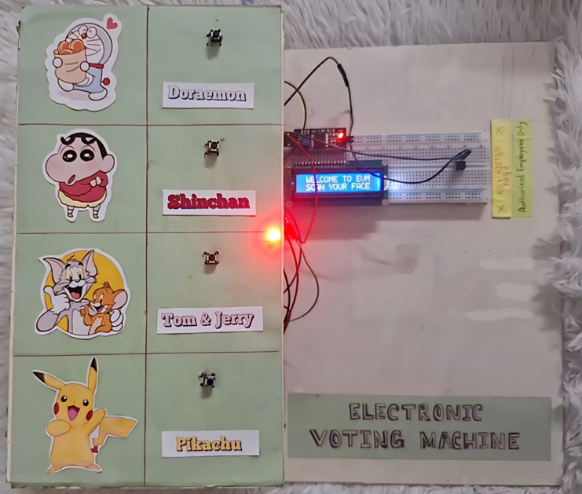

Fig. 1. Experimental Prototype of the Arduino-based electronic voting machine (overall physical model with candidate panel)

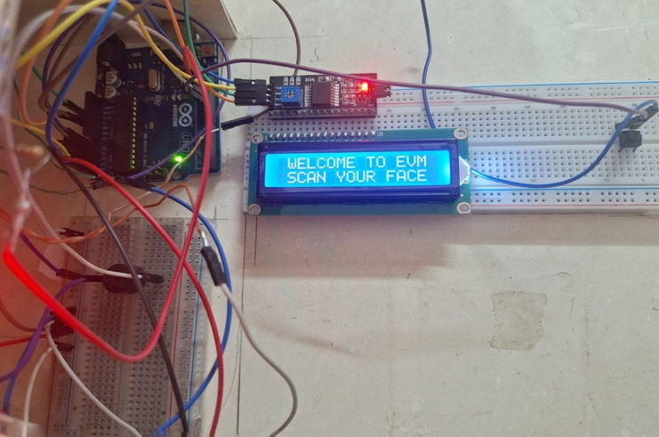

Fig. 2. Internal circuit and testing setup

IV. Results and Discussions

A. Simulation Analysis
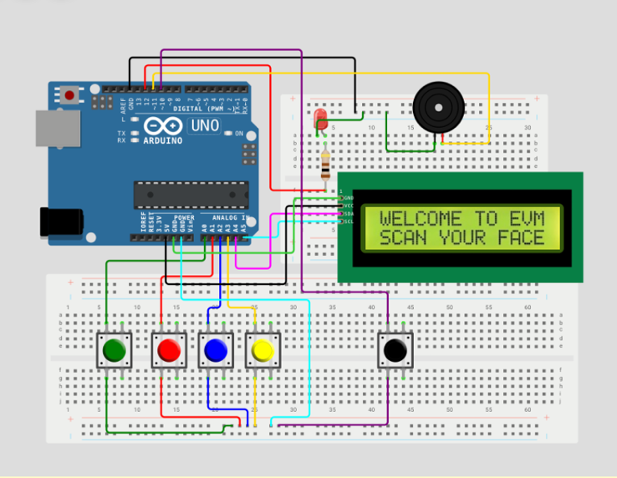Fig. 3. Simulation Result (Welcome message)

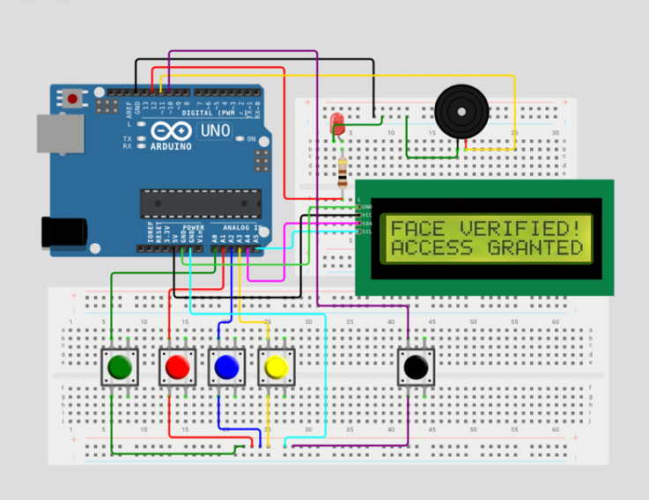

Fig. 4. Simulation Result (Shows Face Is verified)

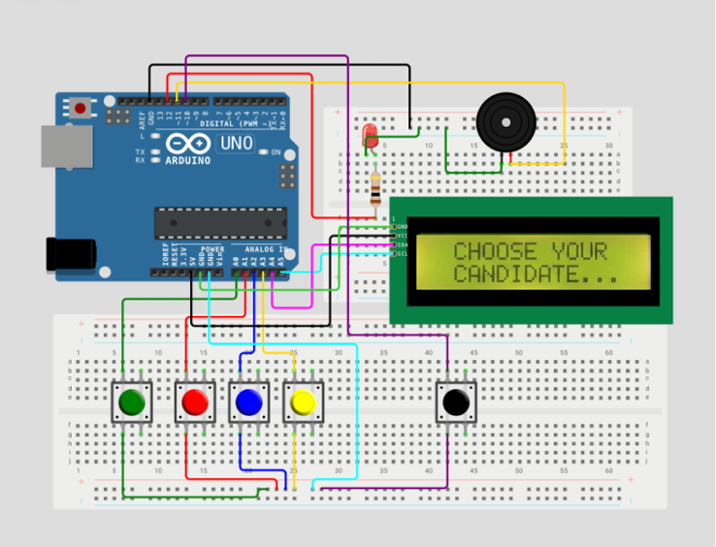

Fig. 5. Simulation Result (Prompts User to choose favorite candidate)

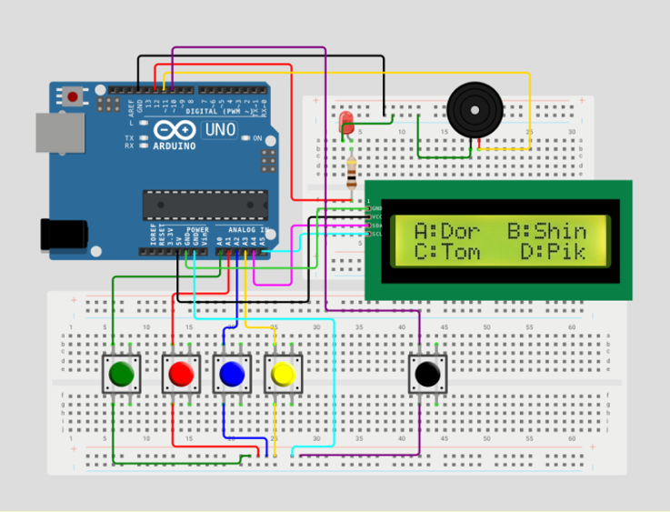

Fig. 6. Simulation Result (Shows candidate lists)

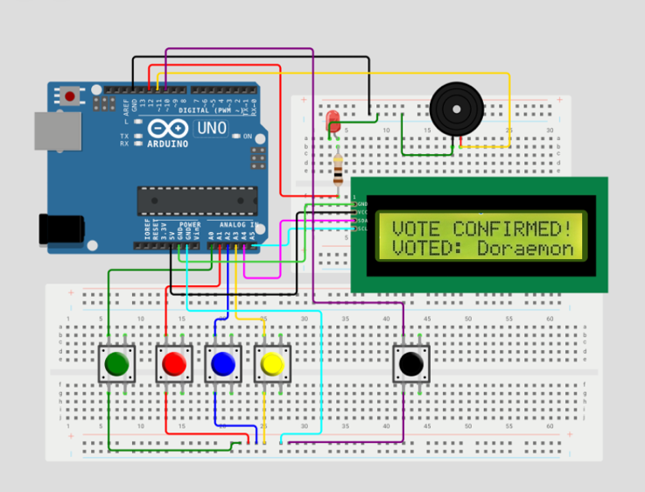

Fig. 7. Simulation Result (Confirmation message after successful vote)

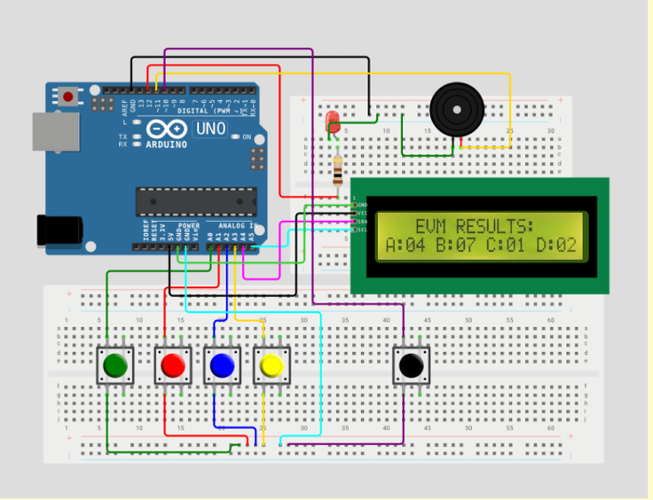

Fig. 8. Simulation Result (After pressing result button LCD shoeing the results)

B. Experimental Result
The functionality and security of the proposed system were verified through a series of physical experiments and integration tests between the Python detection layer and the Arduino hardware. The logic functioned accurately in identifying registered faces and immediately authorizing the voting process, while the tracking mechanism using EEPROM successfully forbade repeated voting by the same individual.
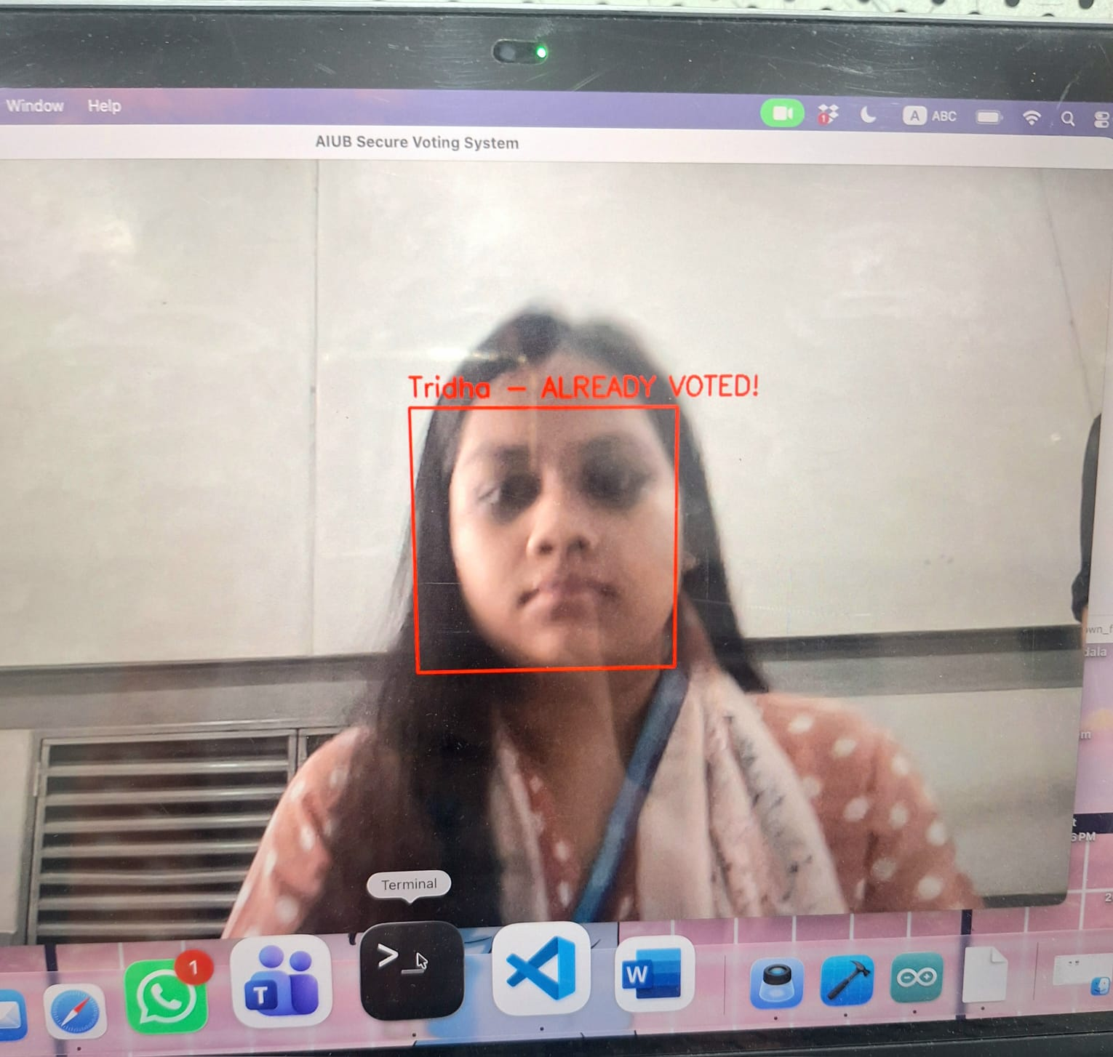
Fig. 9. User trying 2nd time access.

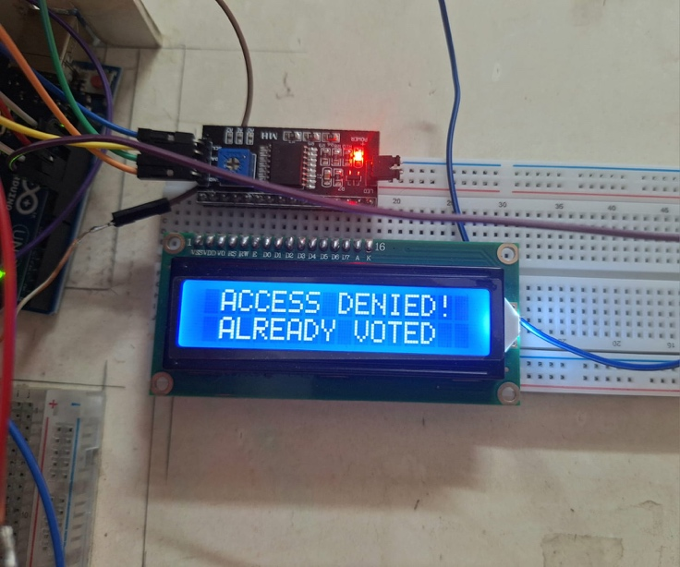
Fig. 10. Access denied for user who already voted.

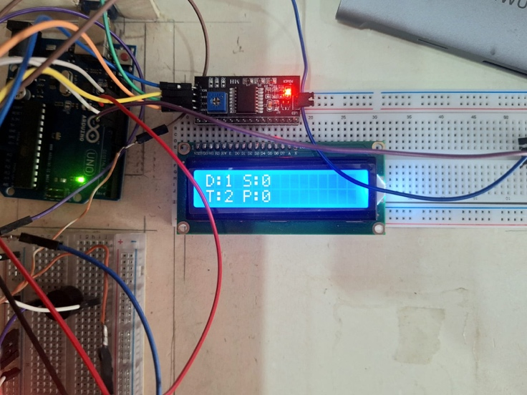
Fig. 11. LCD showing result after casting votes

C. Cost Analysis
Component | Estimated Cost (BDT)
Arduino Uno | 750
Push Buttons (4 pcs) | 80
16×2 I2C LCD | 250
Buzzer & LED | 70
Connecting Wires | 120
Breadboard | 300
Total Estimated Cost | 1570 BDT
The low overall cost makes the system suitable for academic and small-scale voting applications.

D. Limitations
The proposed system faces several technical and practical constraints, including a significant accessibility barrier for aged people, who may struggle with the stability or positioning required for accurate camera detection. Technically, the Face Detection accuracy is highly dependent on environmental lighting, and the system lacks advanced anti-spoofing measures to distinguish between a live person and a photograph. Furthermore, scalability is restricted by the Arduino Uno’s 1 KB internal EEPROM, which limits the number of trackable voter IDs, and the necessity of a constant Serial (USB)connection to a host PC reduces the unit's overall portability.

V. Future enhancements
Although the proposed method is appropriate for small-scale and regulated electoral situations, further enhancements can be implemented to improve security and scalability. The current Face Detection method can be strengthened by adding advanced Liveness Detection algorithms to prevent spoofing attacks using photographs or digital screens. Additionally, integrating a dual-factor biometric layer, such as fingerprint scanning, could provide an even higher level of identity verification
Wireless connectivity can also be implemented to enable simultaneous monitoring and administration of multiple voting machines. In addition, using authenticated firmware update mechanisms before an election may improve system security, but this may also introduce additional implementation challenges.
Post-election, system integrity can be ascertained by employing cryptographic hash algorithms, such as SHA-256, to identify any alterations to the firmware or recorded vote data. Overall, these enhancements are intended to improve transparency and trust in the system, while recognizing that increased system complexity may introduce new challenges.

VI. Conclusion
The development of the Secure Arduino-Based Electronic Voting Machine Using Face Detection successfully demonstrates a modern, high-security approach to electoral integrity. By replacing traditional manual input methods with a Python-based biometric gateway, the system ensures the "one person, one vote" principle while maintaining user convenience. The integration of an Arduino Uno, I2C LCD, and EEPROM provides a robust hardware foundation that remains functional even after power resets, while the tamper-detection logic protects the system from physical manipulation. Despite current limitations regarding environmental lighting and scalability for aged users, this prototype serves as a cost-effective and reliable model for future digital voting innovations.

Acknowledgment
The authors thank Debraj Das, Lecturer, Department of Electrical and Electronic Engineering, for his guidance and technical support during this project. The authors also acknowledge the Department of Electrical and Electronic Engineering of American International University Bangladesh for providing laboratory facilities and resources. Appreciation is extended to all group members for their cooperation and teamwork throughout the implementation of the system.
References
[1] Dr. M. Pravin Kumar, A. Abinaya, R. Boopathi, V. Dhivyadharshini, and P. Harini, “Development of Arduino based Cost Effective and Securable Voting Machine,” in Proc. RTICCT – 2020, Int. J. Eng. Res. Technol. (IJERT), vol. Volume 8, Issue 12, August 2020. [Online]. Available: https://www.ijert.org/research/development-of-arduino-based-cost-effective-and-securable-voting-machine-IJERTCONV8IS12010.pdf
[2] M. A. Al‑jawaherry, “Arduino–Based Electronic Voting Machine,” Tikrit Journal of Pure Science, pp. 1–8, 2018. [Online]. Available: https://doaj.org/article/a6ce2ff9a4b34f51b47be3de7f550132
[3] V. Kiruthika Priya and V. Vimaladevi, “Arduino based Smart Electronic Voting Machine,” Proc. Int. Conf. Trends Electron. Inf. (ICOEI), 2017. [Online]. Available: https://www.semanticscholar.org/paper/Arduino-based-smart-electronic-voting-machine-Priya-Vimaladevi/ea85361cc76383a5eb90eebe05e5df05094e4d3a
[4] Swatanshu Shekhar Singh, Design and Development of Electronic Voting Machine (EVM) Using Arduino, IJSRED‑International Journal of Scientific Research and Engineering Development, vol. 7, no. 1, pp. 791–794, Feb. 2024. [Online]. Available: https://doi.org/10.5281/zenodo.10702316
[5] Abdulkadir H. Alkali, Emmanuel G. Dada, Dauda E. Mshelia, and Sadiq O. Onundi, “Design and Development of an Arduino Based Electronic Voting System,” Int. Refereed J. Eng. Sci. (IRJES), vol. 8, no. 1, Jan. 2019. [Online]. Available: https://www.irjes.com/Papers/vol8-issue1/G0801014857.pdf

